February 2018
Sun | Mon | Tue | Wed | Thu | Fri | Sat
 |  |  |  | 1 S  Open Forum Discussion  11-2  Bring a lunch | 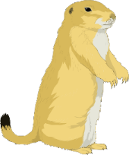  2  Ground Hog’s Day | 3
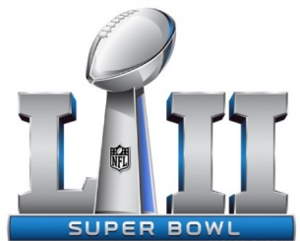  4 | 5 N  Movie Day/Ice Cream Party  11-2  Bring a lunch | 6 S  Wax Museum  11-2  Lunch at Burger King $$ | 7 N  Mindful Thinking/  Creative Writing  11-2  Bring a lunch | 8 S  Mindful Thinking/  Creative Writing  11-2  Bring a lunch | 9 | 10
11 | 12 N  Art/Craft  11-2  Bring a lunch | 13 S  Art/Craft  11-2  Bring a lunch | 14 N&S  Valentine’s Day Party/Calendar Planning 11-2  Lunch Provided | 15  BISG Meeting  12-2  No Transportation Provided | 16 | 17
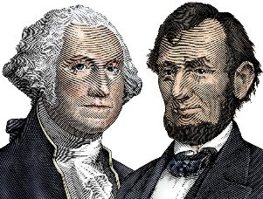  18 | 19 N  Individual strength building11-2  Bring a lunch  President’s Day | 20 S  Individual strength building11-2  Bring a lunch | 21 N  Game Day  11-2  Bring a lunch | 22 S  Game Day/Ice Cream Party  11-2  Bring a lunch | 23 | 24
25 | 26 N  Wii Game Tournaments  11-2  Bring a lunch | 27 S  Wii Game Tournaments  11-2  Bring a lunch | 28 N  Open Forum Discussion  11-2  Bring a lunch | 