September 2017
Sun | Mon | Tue | Wed | Thu | Fri | Sat
Happy Birthday  Joyce K 16 ~ Jay 17  Michael C 17 ~ Mary 21  Tom C 23 ~ Joe 25 |  |  |  |  | 1 | 2
3 | 4  Agency closed | 5  Living Farm  11-2  Please bring a picnic lunch | 6  Self Advocacy Awareness  11-2  Please bring a lunch | 7  Calendar Planning  11-2  Lunch Provided | 8 | 9
10 | 11  Drop In Monday  10-3  Please bring a lunch.  No Transportation Provided  Patriot Day | 12  Lunch at Japanese Restaurant  11-2  $$ | 13  Memory Skills  11-2  Please bring a lunch | 14  Bowling  11-2  Lunch at McDonald’s  $$ | 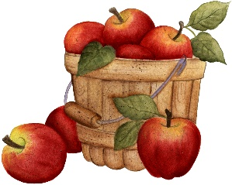  15 | 16
17 | 18  Drop In Monday  10-3  Please bring a lunch.  No Transportation Provided | 19  State Park  11-2  Please bring a picnic lunch | 20  Calming the Mind  11-2  Pleases bring a lunch  Rosh Hashanah | 21  Brain Injury Support Group Meeting  12-2 | 22  Autumnal Equinox  (First Day of Autumn) | 23
24 | 25  Drop In Monday  10-3  Please bring a lunch.  No Transportation Provided | 26  Game Day  11-2  Please bring a lunch | 27  Staff Meeting Day  No Activity | 28  News Station Tour  11-2  Lunch TBD | 29  Yom Kippur | 30

