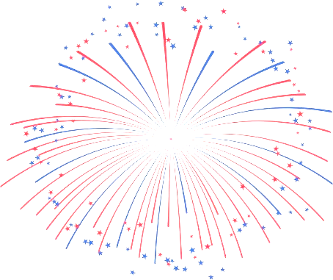
July 2017
Sun | Mon | Tue | Wed | Thu | Fri | Sat
Happy Birthday!  John 23  Ellen 25 |  | Spirit Week: July 17th-July 20th  Monday: Yellow Pig Day-Wear yellow and/or bring a pig. Get ready for math! (Read newsletter for info)  Tuesday: Team Spirit Day-Wear colors/logos/clothes to support you favorite sport or athlete  Wednesday: Weird Hat Day-get creative with your head gear!  Thursday: Twin Day-get with someone and dress as twins (or triplets) |  |  |  | 1
2 | 3  Drop In Monday  10-3  Please bring a lunch.  No Transportation Provided | 4  Independence Day  Agency Closed | 5  Rights and Responsibilities  11-2  Please bring a lunch | 6  Calendar Planning/  Awards Day  11-2  Lunch Provided | 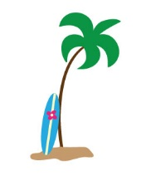  7 | 8
9 | 10  Drop In Monday  10-3  Please bring a lunch.  No Transportation Provided | 11  Bowling  11-2  Lunch at McDonald’s  $$ | 12  Memory Skills  11-2  Please bring a lunch | 13  Burroughs and Chapin  Museum 11-2  Lunch at Burger King  $$ | 14 | 15
16  Spirit Week | 17  Drop In Monday  10-3  Please bring a lunch.  No Transportation Provided  Yellow Pig Day | 18  Decision Making  11-2  Please bring a lunch  Team Spirit Day | 19  Reading Comprehension  11-2  Please bring a lunch  Weird Hat Day | 20  Brain Injury Support Group Meeting  12-2  Twin Day | 21  Brain Injury Conference | 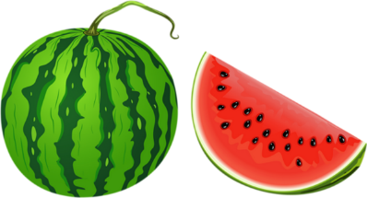  22
23 | 24  Drop In Monday  10-3  Please bring a lunch.  No Transportation Provided | 25  Game Day  11-2  Please bring a lunch | 26  Staff Meeting Day  No Activity | 27  News Station Tour  11-2  Lunch TBD | 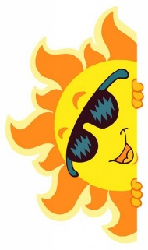  28 | 29
30 | 31  Drop In Monday  10-3  Please bring a lunch.  No Transportation Provided

