February 2017
Sun | Mon | Tue | Wed | Thu | Fri | Sat
 |  |  | 1  Craft Day  11-2  Please bring a lunch | 2  Living Farm  Activity Calendar Planning  11-2  Please bring a picnic lunch  Groundhog Day | 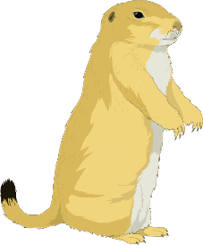  3 | 4
5 | 6  Drop In Monday  10-3  Please bring a lunch.  No Transportation Provided | 7  Memory Exercises  11-2  Please bring a lunch | 8  Bowling  11-2  Lunch at McDonald’s  $$ | 9  Decision Making  11-2  Please bring a lunch | 10 | 11
12 | 13  Drop In Monday  10-3  Please bring a lunch.  No Transportation Provided | 14  Valentine’s Day Party  11-2  Please bring a lunch  Valentine’s Day | 15  Open Forum Disussions  11-2  Please bring a lunch | 16  Brain Injury Support Group  12 noon  Potluck~Please bring a dish to share | 17 | 18
19 | 20  Drop In Monday  10-3  Please bring a lunch.  No Transportation Provided  President’s Day | 21  Burroughs and Chapin  Museum  11-2  Lunch at Arbys  $$ | 22  Staff Meeting  No Activity | 23  Movie at Center  11-2  Please bring a lunch | 24 | 25
26 | 27  Drop In Monday  10-3  Please bring a lunch.  No Transportation Provided | 28  Mardi Gras Celebration  11-2  Lunch provided!

