~ October 2016 ~
Sun | Mon | Tue | Wed | Thu | Fri | 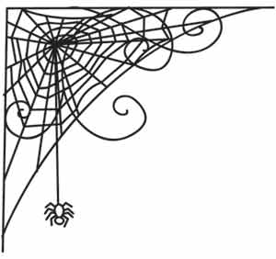  Sat
- Breast Cancer Awareness Month  - Domestic Violence Awareness Month  - Lupus Awareness Month  - National Diabetes Month |  |  |  |  |  | 1
2  Rosh Hashanah Begins at Sundown | 3  Drop In Monday  10-3  Please bring a lunch.  No Transportation Provided | 4  Decision Making  11-2  Please bring a lunch | 5  Rights and Responsibilities  Memory Exercises  11-2  Please bring a lunch | 6  Activity Calendar Planning  and Craft  11-2  Lunch provided! | 7 | 8
9 | 10  Drop In Monday  10-3  Please bring a lunch.  No Transportation Provided | 11  Bowling  Lunch at McDonald’s  11-2 $$  Yom Kippur  Begins at Sunset | 12  Reading Comprehension  11-2  Please bring a lunch | 13  Game Day  11-2  Please bring a lunch | 14 | 15
16 | 17  Drop In Monday  10-3  Please bring a lunch.  No Transportation Provided | 18  Decision Making  11-2  Please bring a lunch | 19  Language and Communication Skills  11-2  Please bring a lunch | 20  Brain Injury Support Group  Meeting  12 noon At Margaritaville  Broadway at the Beach | 21 | 22
23 | 24  Drop In Monday  10-3  Please bring a lunch.  No Transportation Provided | 25  Ghost Stories  11-2  Please bring a lunch | 26  Staff Meeting  No Activity | 27  Halloween Party  11-2 | 28  Fall Festival at  HCDSN Board Office | 29
30 | 31  Drop In Monday  10-3  Please bring a lunch.  No Transportation Provided  Halloween | 