~ July 2016 ~
Sun | Mon | Tue | Wed | Thu | Fri | Sat
Happy Birthday  John D. July 23rd  Ellen L. July 25th |  |  |  |  | 1 | 2
3  From every mountain side  Let Freedom ring.  ~Samuel F. Smith, "America" | 4  Independence Day  Agency Closed | 5  Decision Making  11-2  Please bring a lunch | 6  Rights and Responsibilities  Memory Exercises  11-2  Please bring a lunch | 7  Activity Calendar Planning  11-2  Lunch provided! | 8 | 9
10 | 11  Drop In Monday  10-3  Please bring a lunch.  No Transportation Provided | 12  Imax Theater  Time/Movie: TBD  Please bring a picnic lunch  $$ | 13  Language and Communication Skills  11-2  Please bring a lunch | 14  Craft Day  11-2  Please bring a lunch | 15 | 16
17 | 18  Drop In Monday  10-3  Please bring a lunch.  No Transportation Provided | 19  Black Thai Restaurant and Shopping in Conway  $$ | 20  Memory Exercises  11-2  Please bring a lunch | 21  Brain Injury Support Group Meeting Potluck  11-2  Please bring a dish to share. | 22  Brain Injury Conference | 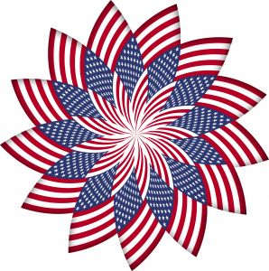  23
24 | 25  Drop In Monday  10-3  Please bring a lunch.  No Transportation Provided | 26  Open Forum  11-2  Please bring a lunch | 27  Staff Meeting  No Activity | 28  Game Day  Please bring a lunch | 29 | 30  6th Annual Motorcycle Ride Fundraiser
31 | Notes:  Please call to schedule pick up times:  Ellen Leftwich 843-349-7250  Jennifer Frettoloso 843-349-7258 |  |  | You have to love a nation that celebrates its independence every July 4, not with a parade of guns, tanks, and soldiers who file by the White House in a show of strength and muscle, but with family picnics where kids throw Frisbees, the potato salad gets iffy, and the flies die from happiness. You may think you have overeaten, but it is patriotism. ~Erma Bombeck

